Egypt University of Informatics
Faculty of Computing & Information Sciences
Data Analysis Course (C-DE211)

Predictive Analysis of EGX30
Stock Trends (2021–2026)
A look at whether Egyptian stock prices are growing for real, and whether different sectors move together or separately.
Submitted by:
Mohamed Reda (24-101232)
Yousef Mohamed (24-101174)
Taha Ahmed (24-101520)
Adham Abdo (24-101016)
Spring 2026

Introduction
The Egyptian Exchange (EGX) is one of the oldest stock markets in the Middle East. The EGX30 index tracks Egypt’s 30 biggest and most traded companies, covering sectors like banking, real estate, telecom, finance, and industry. It gives us a good picture of how the Egyptian economy is doing.
Between 2021 and 2026, Egypt went through major economic changes: the Egyptian pound lost a lot of its value, inflation went up, and the Central Bank kept adjusting interest rates. All of this raises a simple question: are Egyptian stocks actually growing, or are the price changes just random noise?
In this report, we look at 10 of the top EGX30 stocks over 5 years (January 2021 to February 2026). We use charts, correlation analysis, and statistical tests to find out if the growth is real, and whether different sectors behave the same way or differently.

Research Question
Are EGX30 stock prices actually going up over time, or is it just random day-to-day movement? And do different sectors (like banking and real estate) go up at the same pace, or do they behave differently?

Hypothesis
Hypothesis 1 — Is each stock’s growth real?
- H₀ (Null): The average daily return is zero — meaning price goes up and down randomly with no real direction.
- H₁ (Alternative): The average daily return is not zero — meaning there’s a real trend (up or down).
Hypothesis 2 — Do sectors move differently?
- H₀ (Null): Banking and Real Estate stocks have similar daily returns — no real difference between them.
- H₁ (Alternative): There is a significant difference between the two sectors.

Population of Interest
We looked at daily stock prices for 10 companies listed on the EGX30, from January 3, 2021 to February 4, 2026. These 10 stocks cover five major sectors of the Egyptian economy: Banking (3 stocks), Real Estate (3 stocks), Finance (2 stocks), Telecom (1 stock), and Industry (1 stock).

Sampling Method
We didn’t take a sample — we used every single trading day available. Each stock has 1,234 daily records, giving us 12,340 total data points across all 10 stocks. This means there’s no sampling bias because we’re looking at the complete picture, not just a slice of it. The data comes from a Kaggle dataset called “EGX Egyptian Stocks 2021–2026” which pulls from official exchange records.

Bias Identification
Even though we used all available data, there are still some biases to be aware of:
- Survivorship Bias: We only looked at stocks that are still in the EGX30 today. Companies that failed or got removed from the index aren’t included, which might make the market look more successful than it really is.
- Selection Bias: We picked 10 out of 30 stocks, focusing on the most well-known ones. The other 20 might behave differently.
- Currency Bias: All prices are in Egyptian Pounds. Since the pound lost a lot of value during this period, stock prices going up in EGP doesn’t necessarily mean investors are richer in real terms. We didn’t adjust for inflation in this study.

Dataset Description
We got our data from Kaggle. Each stock has a CSV file with 1,234 rows (one row per trading day). Here are the columns in each file:
Column | Type | What It Means
Date | Date/Time | The trading day
Open | Number | Price when the market opened that day
High | Number | Highest price the stock hit during the day
Low | Number | Lowest price the stock hit during the day
Close | Number | Price when the market closed (this is the main one we analyze)
Volume | Number | How many shares were bought/sold that day
Dividends | Number | Cash paid out to shareholders (usually 0)
Stock Splits | Number | Whether the stock was split (usually 0)
dailyReturn | Calculated | How much the price changed from yesterday, as a percentage (we calculated this ourselves)
Total data points: 12,340 (1,234 days × 10 stocks).

The 10 Stocks We Analyzed
Ticker | Company | Sector | Start | End | Growth
TMGH | Talaat Moustafa Group | Real Estate | 6.14 | 90.20 | +1,369%
ETEL | Telecom Egypt | Telecom | 8.56 | 83.30 | +874%
CANA | Suez Canal Bank | Banking | 4.50 | 40.72 | +805%
SWDY | El Sewedy Electric | Industry | 8.94 | 80.88 | +805%
PHDC | Palm Hills Development | Real Estate | 1.22 | 8.86 | +628%
COMI | Commercial Int. Bank | Banking | 27.46 | 136.50 | +397%
CIEB | Credit Agricole Egypt | Banking | 5.31 | 25.73 | +384%
HRHO | EFG Hermes Holding | Finance | 8.06 | 29.38 | +265%
CCAP | Citadel Capital | Finance | 1.44 | 3.54 | +147%
OCDI | SODIC | Real Estate | 14.34 | 16.77 | +17%

Analysis
We cleaned the data, calculated how much each stock changed day-to-day, and then created charts and ran statistical tests to answer our two research questions. Here are our findings:

Price Trends Over Time
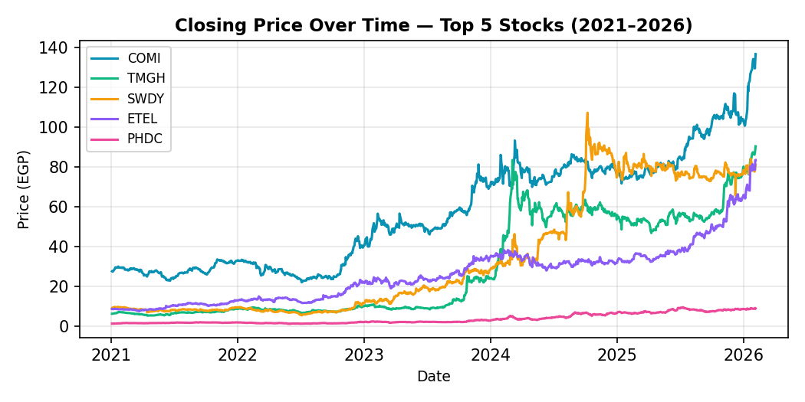
Figure 1: How the top 5 stock prices changed over 5 years.
This chart shows the closing price of the 5 best-performing stocks from 2021 to 2026. All of them clearly went up over time. COMI reached the highest price (136.50 EGP), while TMGH had the most dramatic jump — going from around 6 EGP to over 90 EGP. The fact that all 5 stocks from different sectors grew at roughly the same time suggests that something bigger than just one company or one sector is pushing prices up — likely economy-wide factors like currency devaluation and inflation.

Trading Volume
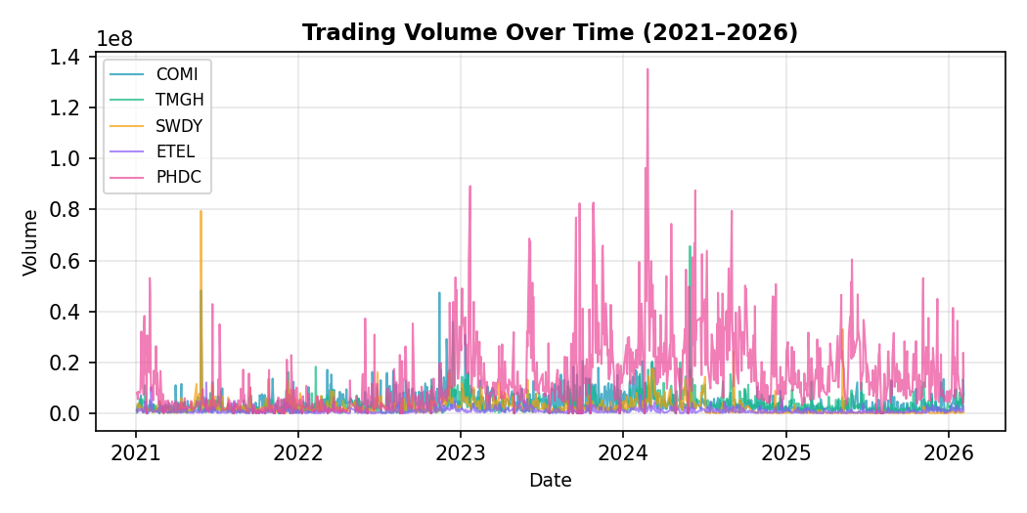
Figure 2: How many shares were traded each day.
This chart shows trading activity. PHDC (Palm Hills) is by far the most actively traded stock. When you look at the spikes, they tend to happen across multiple stocks at the same time. This tells us that when big news hits (like a Central Bank decision), the whole market reacts at once — not just one sector.

How Stocks Relate to Each Other (Correlation)
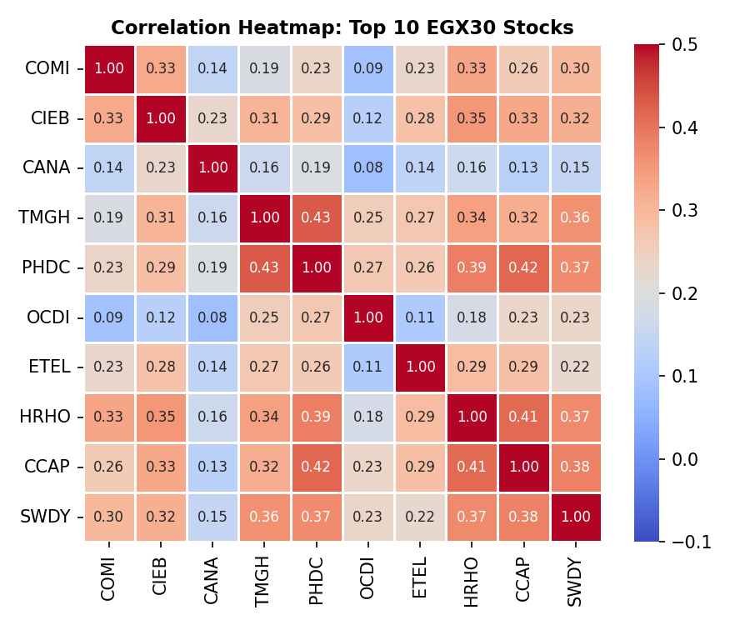
Figure 3: Correlation heatmap showing how similarly each pair of stocks moves.
This heatmap shows the correlation between every pair of stocks. A value of 1.0 would mean they move in perfect sync; 0.0 means no relationship at all. The strongest pair is TMGH–PHDC (both real estate) at 0.43, which is moderate. Most pairs are in the 0.15–0.40 range, meaning stocks tend to move in the same general direction but not in lockstep. CANA (Suez Canal Bank) is the most independent stock — it barely correlates with anything else.

Which Sector Grew the Most?
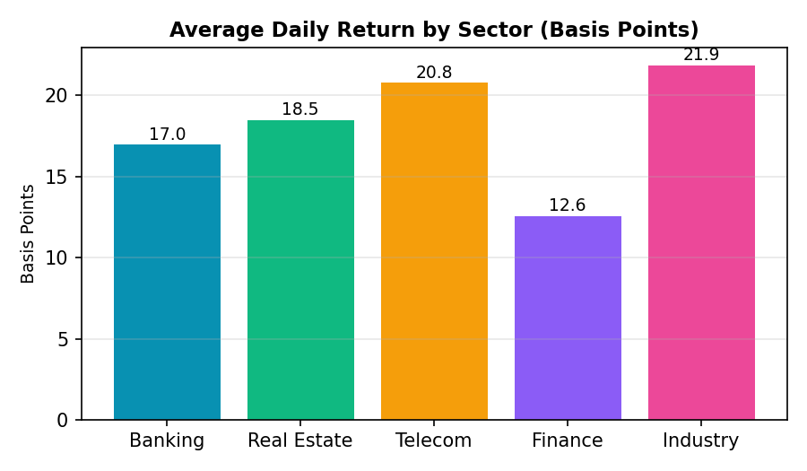
Figure 4: Average daily return per sector, measured in basis points (1 bp = 0.01%).
Industry (SWDY) and Telecom (ETEL) had the highest average daily returns, while Finance (HRHO, CCAP) had the lowest. But here’s the key finding: even though the bars look different, our statistical test (shown later) found that these differences are too small to be meaningful. Statistically, all sectors grew at roughly the same pace.

Do Sectors Move Together?
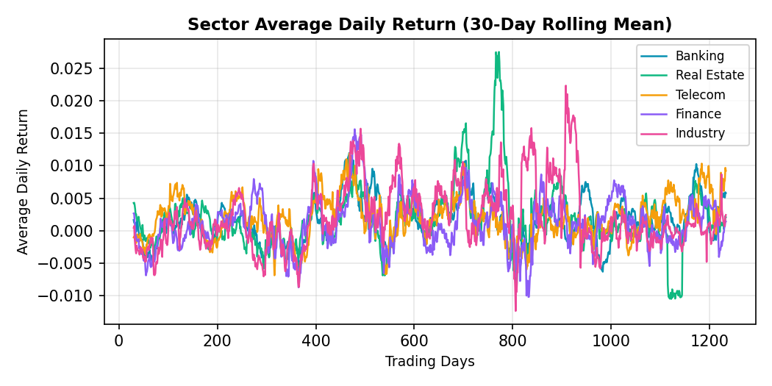
Figure 5: 30-day average of daily returns for each sector, plotted on top of each other.
This is one of the most telling charts. All five sector lines move almost identically — when one goes up, they all go up, and when one dips, they all dip together. This confirms that the Egyptian market moves as one big unit, not as separate sectors. The reason is likely that macro forces (currency, inflation, interest rates) affect every company at the same time.

Hypothesis Testing
We used two statistical tests to answer our research questions. Here’s how they work in simple terms:

Test 1: Is the Growth Real? (1-Sample T-Test)
What we’re testing: For each stock, we check if its average daily price change is meaningfully different from zero. If it is, that means the stock is genuinely trending upward (not just bouncing around randomly).
The rule: If the p-value is below 0.05, we say the result is statistically significant — the growth is real. If it’s above 0.05, we can’t be sure.
Step 1 — Hypotheses:
- H₀: Average daily return = 0 (price movement is random).
- H₁: Average daily return ≠ 0 (there’s a real trend).
Step 2 — Significance level: α = 0.05 (95% confidence).
Step 3 — Run the test: We used Python’s scipy.stats.ttest_1samp on each stock’s daily returns.
Step 4 — Results:
Stock | Avg Return | t-stat | p-value | What It Means
COMI | 0.00149 | 2.705 | 0.0069 | Real trend ✓
CIEB | 0.00153 | 2.395 | 0.0168 | Real trend ✓
CANA | 0.00207 | 3.065 | 0.0022 | Real trend ✓
TMGH | 0.00255 | 3.243 | 0.0012 | Real trend ✓
PHDC | 0.00196 | 2.602 | 0.0094 | Real trend ✓
OCDI | 0.00104 | 1.007 | 0.3141 | Inconclusive ✗
ETEL | 0.00208 | 3.353 | 0.0008 | Real trend ✓
HRHO | 0.00130 | 2.056 | 0.0400 | Real trend ✓
CCAP | 0.00122 | 1.369 | 0.1714 | Inconclusive ✗
SWDY | 0.00219 | 2.688 | 0.0073 | Real trend ✓
Bottom line: 8 out of 10 stocks have p-values below 0.05, which means their growth is statistically real — not random luck. The two that didn’t pass (OCDI and CCAP) had either very weak growth or too much volatility for the test to give a clear answer.

Test 2: Do Sectors Behave Differently? (2-Sample T-Test)
What we’re testing: We compare the daily returns of Banking stocks against Real Estate stocks (and Banking vs Finance) to see if one sector grows faster than the other.
Step 1 — Hypotheses:
- H₀: No significant difference between sectors.
- H₁: There is a significant difference.
Step 2: α = 0.05.
Step 3: We pooled all daily returns from each sector and compared them using scipy.stats.ttest_ind.
Step 4 — Results:
Comparison | t-stat | p-value | What It Means
Banking vs Real Estate | -0.249 | 0.803 | No real difference — they move together
Banking vs Finance | 0.702 | 0.483 | No real difference — they move together
Bottom line: Both p-values are way above 0.05 (0.803 and 0.483), so there’s no significant difference between sectors. Banking, Real Estate, and Finance stocks all grow at roughly the same rate. The market moves as one unit.

How These Two Tests Fit Together
At first, these two results might seem contradictory: “Stocks have real trends” but also “Sectors aren’t different.” But they’re actually answering two different questions:
- Test 1 says: “Yes, stocks are genuinely going up — it’s not random.”
- Test 2 says: “And they’re all going up together at the same pace.”
This makes perfect sense when you think about what happened in Egypt during 2021–2026. The Egyptian pound lost a huge amount of value, inflation was high, and the Central Bank kept raising interest rates. These forces pushed all stock prices up across the board — not just one sector. So every stock has a real upward trend (Test 1), AND all sectors follow the same rhythm (Test 2). They’re two sides of the same coin: the Egyptian market is driven by shared economic forces, not random company-by-company events.

Conclusion
Here are the three main takeaways from our analysis:
- The growth is real. 8 out of 10 stocks passed the statistical test. Their prices going up over 5 years isn’t random noise — it’s a genuine trend.
- The whole market moves together. There’s no meaningful difference between sectors. When the market goes up, all sectors go up. When it drops, everything drops. Trying to diversify only within EGX30 stocks won’t protect you much.
- It’s all about the economy. The EGP devaluation, rising inflation, and Central Bank policy are the biggest drivers. They explain both why stocks grew (Test 1) and why they grew together (Test 2).
In simple terms: investing in Egyptian stocks during this period wasn’t gambling — there were real, measurable upward trends. But the market behaves as one big system, so picking different sectors doesn’t give you much variety.

Potential Issues
- Survivorship Bias: We only looked at stocks that are still listed. Companies that failed and got removed aren’t in our data, which might make the market look better than it actually is.
- Inflation not accounted for: Stock prices went up in Egyptian pounds, but the pound itself lost a lot of value. In real purchasing power, the gains might be smaller than they appear.
- Only 10 of 30 stocks: We analyzed a third of the EGX30. The other 20 stocks might tell a different story.
- Missing data filled with last known value: When data was missing, we used the previous day’s price. This is standard, but it could hide periods where trading was suspended.
- No external data: We didn’t include the USD/EGP exchange rate, inflation numbers, or Central Bank decisions in our analysis. Adding these could help explain why the market moved the way it did.

